Fixguru Sprint 0

Who's Fixguru?
- They sell boxes like any type of boxes....
- Already made boxes
- Custom boxes
- Sell to who ?
- Small to large businesses
- Johnson's childhood friend

Current Business process
Quotation → Proforma → pick list → schedule delivery → issue Invoice → Credit Note (if needed)
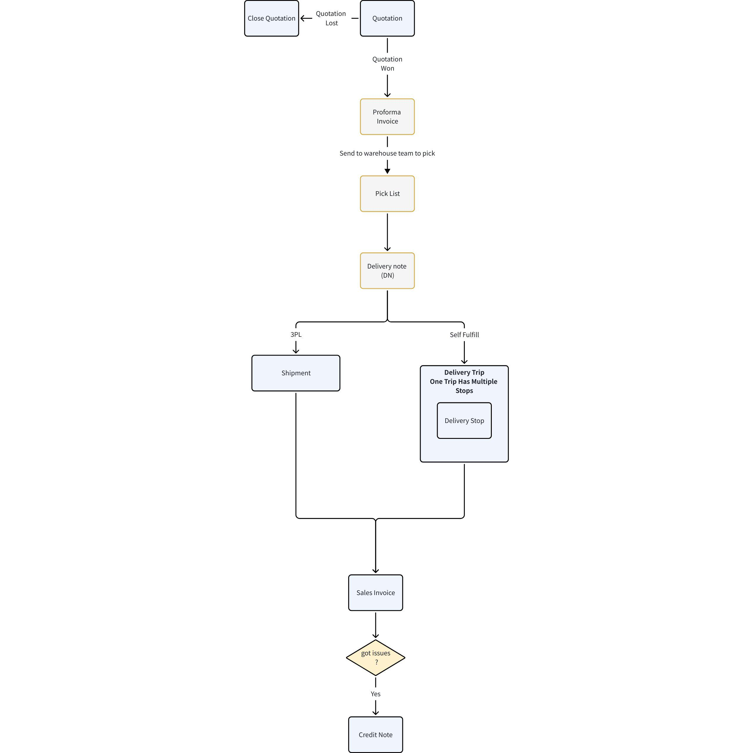

MAIA Business process

MAIA Business process
Quotation → Sales Order (SO) → Proforma → Delivery Note (DN/DO) → Invoice → Credit Note (if needed)
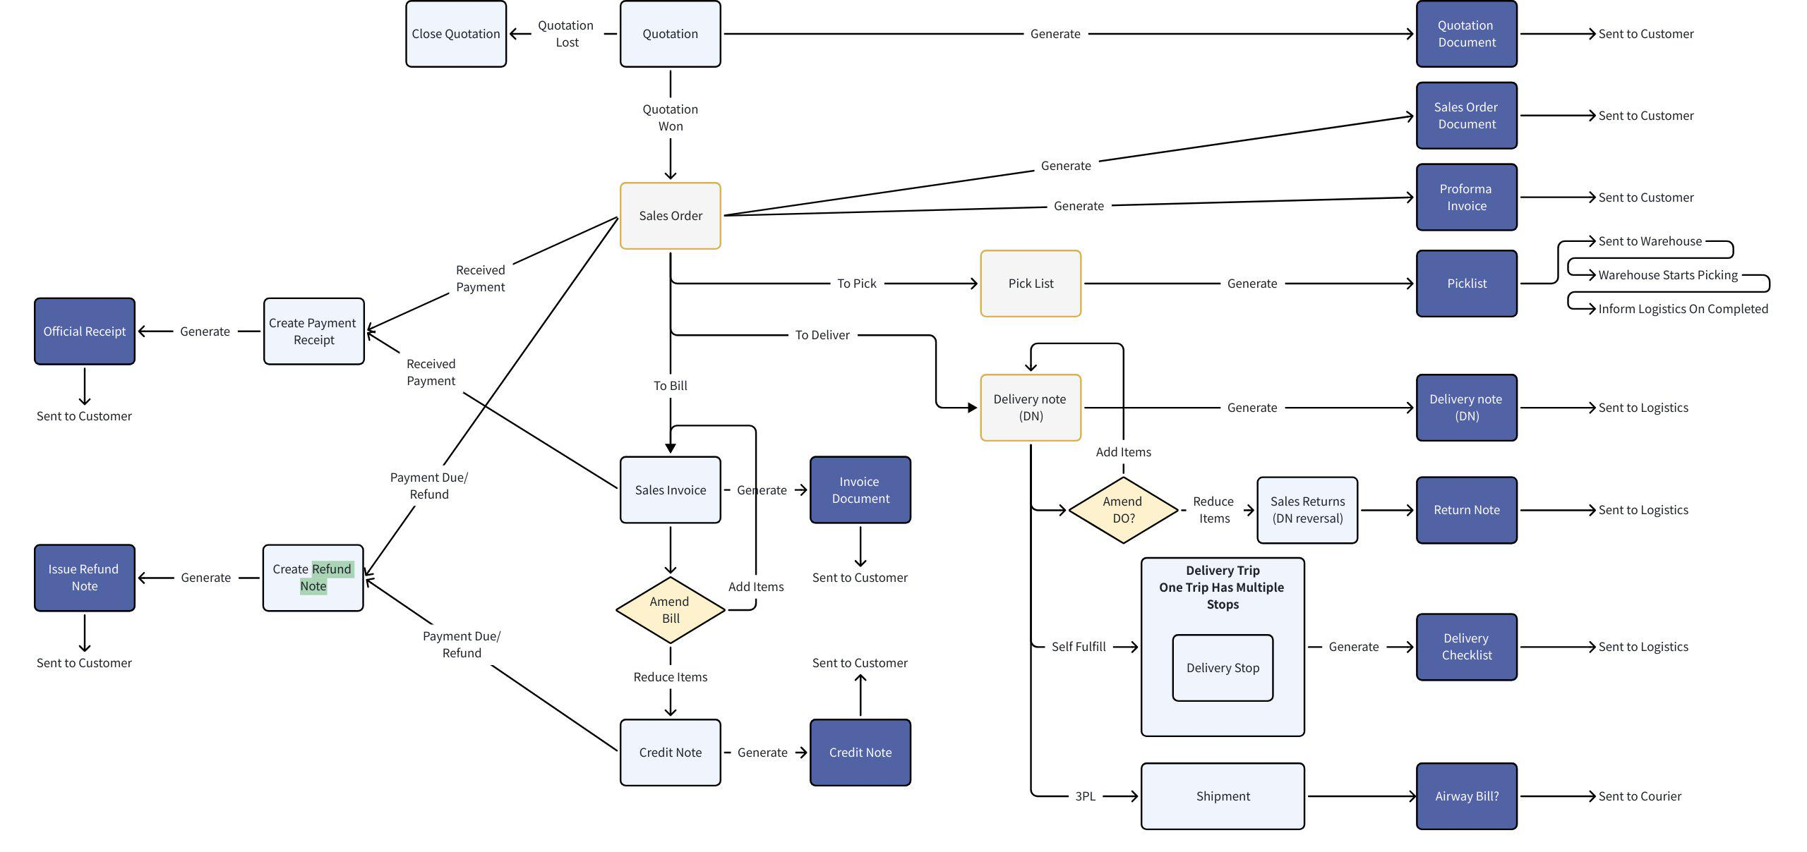
Order-Centric Record Grouping
MAIA adopts an order-centric record grouping model, where the Sales Order acts as the central record. All related documents are linked to the SO, providing:
- Traceability: A clear audit trail from quotation to invoice, ensuring every action is tied to a single order reference.
- Editability During Proforma Stage: By grouping related documents under the SO, any changes made at the proforma invoice stage remain easy to edit and manage. This allows teams to refine order details (quantities, pricing, discounts) before finalization.
- Final Invoice Accuracy: The final invoice will always reflect the last agreed-upon version, minimizing errors and disputes.
- Invoice Traceability
Every invoice is linked directly back to its originating Sales Order (SO). This means stakeholders can always trace invoices to the specific order they belong to, even in cases where one order may generate multiple invoices (e.g., partial deliveries or staged billing).
- Refund Handling:
- Refund Note: Used to record and track refunds or return transactions giving finance team visibility into adjustments.
- Credit Note: Only issued after the invoice is finalized, ensuring compliance with accounting standards and maintaining accurate financial reporting.
- List of Documents under 1 Sales Order
Type of documents under 1 Sales order
Sales Order | Quotation
Sales Order | Proforma
Sales Order | Pick list
Sales Order | Delivery Note (DO)
Sales Order | Delivery Trip
Sales Order | Invoice
Sales Order | Credit note
Sales Order | Receipt
Sales Order | Refund Note

Business Process Steps
The following steps outline the end-to-end order-to-cash workflow within MAIA, ensuring consistency, traceability, and alignment between sales, logistics, and finance.
Step 1: Quotation Creation
- A Sales Representative creates a quotation to capture initial pricing, terms, and product details for the customer.
- This document serves as the starting point of the sales lifecycle.
Step 2: Proforma Invoice Generation
- A Proforma Invoice is generated once the quotation is reviewed and the customer provides confirmation.
- This acts as a formal order confirmation before fulfillment begins.
Step 3: Picklist Preparation
- A Picklist is generated and shared with the warehouse or operations team.
- The picklist outlines all items, quantities, and storage locations to guide accurate picking and packing.
Step 4: Delivery Note (DO) Creation
- A Delivery Note (DO) is generated once items are picked and packed.
- The DO serves as the official record of goods ready to be shipped.
Step 5: Delivery Trip & Shipment Scheduling
- A Delivery Trip is created to consolidate all Delivery Notes scheduled for dispatch within the same day.
- This document enables drivers and logistics teams to efficiently manage deliveries across multiple orders.
Step 6: Invoice
- Once delivery is completed, a final invoice is generated.
- The invoice reflects the agreed terms, final product quantities, and payment requirements, serving as the legal and financial record of the transaction.

Customization points

1. API Integrations
- Direct integration with third-party systems such as CRMs and ERPs.
- Initial integration target: AutoCount.
- Warehouse Management System (WMS) integration for inventory sync and operational alignment.

Workflow Automation
- Automation of key processes unique to the client’s operations, e.g.:
- Automatic creation of a Delivery Note (DO) upon finalization of a Sales Order.

UI/UX Modifications
- Tailored dashboards and analytics to enhance usability, such as:
- Overall sales overview.
- Outstanding payments monitoring.

Custom Modules

Calculation Logic

Custom Box Quotation calculation Module designed based on IAM’s Excel models: RSC Box Calculator
[RSC Custom Made Calculation.pdf]

RSC Sheet (calculation logic provided by IAM Worldwide Sdn Bhd).
[Custom Made - RSC 1024 (1).xlsx]

Diecut Sheet (calculation logic provided by IAM Worldwide Sdn Bhd).
[Custom Made - Diecut 0825.xlsx]

Chatbot

ERP

Approval Processes
MAIA incorporates a robust approval workflow engine to safeguard compliance and ensure management oversight across critical business processes. Approvals are not tied to individual users but instead operate on a role-based model, meaning any user assigned to the designated role group can perform the required approval. This ensures flexibility, accountability, and continuity even if specific users are unavailable.
Approval process | Triggers | Who needs to approve
- Quotation / Sales Order approval when selling price falls below minimum threshold. | Selling price < minumum price (get from autocount) | - Management
- Management approval required if a customer approaches their credit limit prior to creating a Sales Order. | - Set reminder at 80% | - Management
- Delivery Note(DO) approval required if the Delivery Note or Deliver Note items differ from the original Sales Order. | DN Product item != Sales Order Product items | - Sales  - Management
- Delivery Note(DO) Approval required if the order is Cash payment | - Payment to confirm before issue DO  How to confirm payment  Once customer confirmed with signature, then only it will be deemed as confirmed sales and proceed to issue packing list | - Sales  - Management
- Credit terms to follow customer credit terms (any outstanding payment following their credit term will need to be sent to get approval | - Credit customer who has outstanding payment from their existing credit term | - Management

- Quotation / Sales Order approval when selling price falls below minimum threshold.
- Management
- Get from autocount from "Stock Item"
- Management approval required if a customer approaches their credit limit prior to creating a Sales Order.
- Set reminder at 80%
- Delivery Note(DO) approval required if the Delivery Note or Deliver Note items differ from the original Sales Order.
- Admin
- Reminder sent to sales and management
- Delivery Note(DO) Approval required if the order is Cash payment
- Admin and management
- Cash cus to pay before issue DO
- Credit terms to follow customer credit terms (any outstanding payment following thier credit term will need to send got approval)<--- Management for approval

Custom Notification
Automated reminders to drive timely actions and improve operational efficiency:
Notification is sent to dedicated user( order process)
- Stock availability notifications.
Notifications | Scenarios | Triggers | Notification to siapa?
- low stock product | Notification trigger when item is low in stock | When the item is at the lowest minimum threshold  Explore to see whether you can explore using the Past 3 Months average sales quantity as the threshold | Sales  Admin  Management
- out of stock product | Notification triggers when item is out of stock | Product quantity = 0 | Sales  Admin  Management
- Delivery status updates.
Status | Status sent to whom ?
- Packing | Dedicated Sales agent
- Packed | Dedicated Sales agent
- Schdeuled | Dedicated Sales agent
- loading | Dedicated Sales agent
- Out for delivery | Dedicated Sales agent
- Delivered | Dedicated Sales agent

- Follow-up reminders for quotations.
Alerts if Sales Order is not converted to DO within 7 days.
- Dedicated sales agent reminder
Reminder to sent | Triggers | Status sent to whom ?
- Alerts if Sales Order is not converted to DO within 7 days. | No Delivery note created after 7 Days | Sales Agent (User Specific)
- Customer inactivity reminders (no orders for every 30 days). From last invoice date
How often | Triggers | Who receives notification ? | Is it user specific ?
30 days  60 days  90 days | Eg. Event or Schedule | eg.Sales agent | Eg. Yes
- Outstanding payment reminders
- Credit term
- Credit limit
- Any outstanding payment of the respective customers

Status | Triggers | Scenarios | Who receives notification ?
Customer outstanding payments nearing end of Credit terms | Event | 10 days before end of credit term | Dedicated Sales agent
Credit limit alerts for customers almost exceeding their limit. | Event | 80% credit limit | Dedicated Sales agent
Reminder for Overpaid customer | Event | Overpaid amount > 0 | Dedicated Sales agent
Dedicated Sales Agent reminders to send a copy of invoice to customers once delivery is completed | Event | When final invoice is generated | Dedicated Sales agent

Inventory Management (Baseline & Integration)
Objective: Ensure accurate stock availability throughout the order-to-fulfillment cycle, while keeping accounting stock authoritative in AutoCount (or integrated systems).
Stock Tracking Steps
- SKU Synchronization: Sync unique SKUs (catalog/inventory master) from the Warehouse Management System (WMS) or accounting system into MAIA.
- Quantity Ownership: MAIA does not maintain stock count as the system of record; quantities remain authoritative in AutoCount/WMS.
- Real-Time Validation: During SO/DN creation, MAIA validates stock quantity against AutoCount (or WMS) to prevent oversell.
- Delivery Note Creation: Delivery note (DO) issuance reflects into AutoCount immediately (created on the spot) to keep inventory movement aligned.
- Any stock returns from Return Note - push back into Autocount "Sales - Delivery Returns
Notes
- Day-to-day stock movements are tracked through orders in MAIA for operational visibility; replenishment/restock is performed in AutoCount/WMS and can be pulled into MAIA via sync.
- Optional enhancements: safety stock rules, low-stock alerts, channel allocation rules, and per-outlet availability displays.
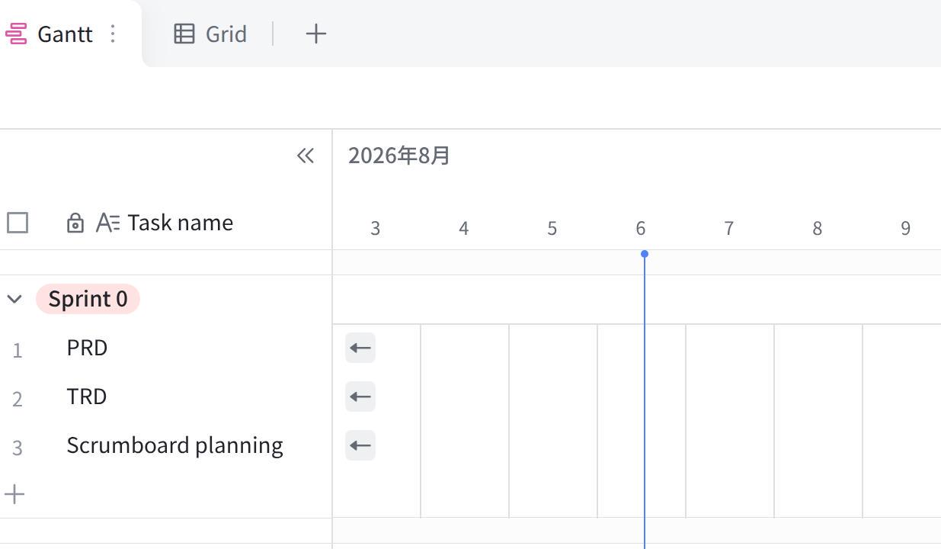
点击图片可查看完整表格

